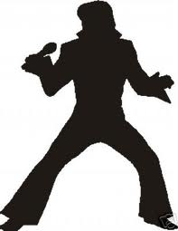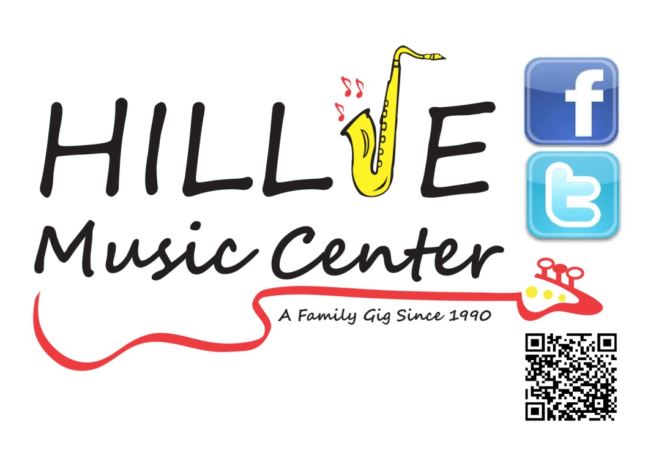
75% OFF all Guitar Straps featuring ELVIS or THE SIMPSONS!!!
(While Supplies Last)
